Experiment Number : 05 Date: 5-02-26

INHERITANCE
Aim:
To understand and implement inheritance concepts in Java.
PRE LAB EXERCISE
QUESTIONS
- What is inheritance?
Inheritance is an object-oriented programming (OOP) feature where one class (child/subclass) acquires the properties and behaviors (variables and methods) of another class (parent/superclass).
It helps in:
- Reusing existing code
- Extending functionality
- Reducing duplication
Example:
A class Dog can inherit from a class Animal.

- What is code reusability?
Code reusability means using existing code again without rewriting it.
Benefits:
- Saves time
- Reduces errors
- Improves maintainability
Inheritance, functions, and libraries all support code reusability.

- What is the use of extends keyword?
In Java, the extends keyword is used to:
- Create a child class from a parent class
- Enable inheritance
- Allow the subclass to use the parent’s variables and methods
Example:
class Animal { }
class Dog extends Animal { }
Here, Dog inherits everything from Animal.

IN LAB EXERCISE
Objective:
To implement all types of inheritance.
PROGRAMS:
Student Result System (Single Inheritance)
Question:
A school wants to store student details and calculate marks. Create a base class Student and a derived class Result.
Code:
package tutorial;
class Student {
String name;
int rollNo;

void getDetails() {
name = "Siva";
rollNo = 27;
}
}

class Result extends Student {
int marks = 99;

void display() {
System.out.println("Name: " + name);
System.out.println("Roll No: " + rollNo);
System.out.println("Marks: " + marks);
}
}

public class singlein {
public static void main(String[] args) {
Result r = new Result();
r.getDetails();
r.display();
}
}
Output:
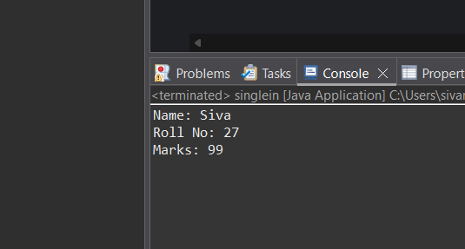
2. Bank Account System (Hierarchical Inheritance)
Question:
A bank has Savings and Current accounts. Both inherit from a common Account class.
Code:
package tutorial;
class Account {
void showAccountType() {
System.out.println("Bank Account");
}
}

class SavingsAccount extends Account {
void interest() {
System.out.println("Savings Account gives interest");
}
}

class CurrentAccount extends Account {
void overdraft() {
System.out.println("Current Account supports overdraft");
}
}

public class mulin {
public static void main(String[] args) {
SavingsAccount s = new SavingsAccount();
CurrentAccount c = new CurrentAccount();
s.showAccountType();
s.interest();
c.showAccountType();
c.overdraft();
}

}

Output:
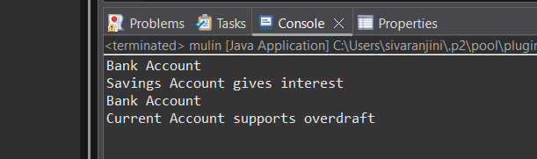
3. Vehicle System (Multilevel Inheritance)
Question:
A company classifies vehicles as Vehicle → Car → ElectricCar.
Code:
package tutorial;
class Vehicle {
void start() {
System.out.println("Vehicle starts");
}
}
class Car extends Vehicle {
void fuelType() {
System.out.println("Car uses petrol");
}
}
class ElectricCar extends Car {
void battery() {
System.out.println("Electric car uses battery");
}
}
public class hiein {
public static void main(String[] args) {
ElectricCar e = new ElectricCar();
e.start();
e.fuelType();
e.battery();
}
}
Output:
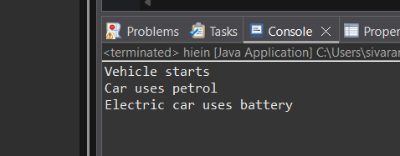
POST LAB EXERCISE
- Why Java does not support multiple inheritance using classes and how it is implemented?
Java does not support multiple inheritance through classes because:

Reason: To avoid ambiguity (Diamond Problem)
If two parent classes have the same method, the child class will not know which one to inherit.
This creates method ambiguity, known as the diamond problem.

How Java solves it:
Java supports multiple inheritance through interfaces, not classes.
A class can extend only one class but can implement multiple interfaces.
Example:
interface A {
void show();
}

interface B {
void display();
}

class C implements A, B {
public void show() { }
public void display() { }
}
Thus, Java achieves multiple inheritance safely using interfaces.

- What is the role of the super keyword? Give examples.
The super keyword refers to the parent class.
It is used for three main purposes:
(1) To call parent class constructor
class A {
A() { System.out.println("Parent"); }
}
class B extends A {
B() {
super();
System.out.println("Child");
}
}
(2) To access parent class variables
class A {
int x = 10;
}
class B extends A {
int x = 20;
void show() {
System.out.println(super.x); // prints parent x = 10
}
}
(3) To call parent class methods
class A {
void display() { System.out.println("Parent"); }
}
class B extends A {
void display() {
super.display(); // parent method
System.out.println("Child");
}
}
- Can a child class access private members of the parent class? Why?
No, a child class cannot access private members of the parent class.
Reason:
- Private members belong strictly to the class in which they are declared.
- They are not visible outside the class — not even to subclasses.
But they can be accessed indirectly:
Through public or protected getters and setters.
Example:
class A {
private int data = 10;
public int getData() { return data; }
}
- Explain why hybrid inheritance is not supported in Java.
Hybrid inheritance = Multiple + Multilevel inheritance combined
Java does not support hybrid inheritance using classes because:
- It involves multiple inheritance, which causes ambiguity.
- It can create complex class structures and confusion.
- It may lead to the diamond problem, where the child class inherits the same method from multiple paths.
What Java supports instead:
Hybrid inheritance can be simulated using interfaces, because interfaces avoid ambiguity.

Result:

Thus the different types of inheritance were implemented and executed successfully.

ASSESSMENT

Description | Max Marks | Marks Awarded
Pre Lab Exercise | 5
In Lab Exercise | 10
Post Lab Exercise | 5
Viva | 10
Total | 30
Faculty Signature

